1.Billdate should display & need to show meaningful Description.
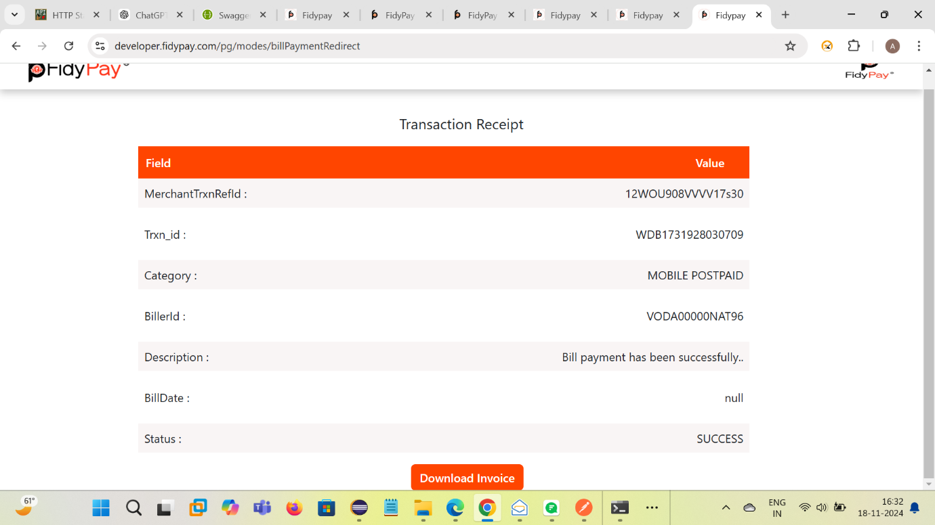

Change Date format and need to show band ref id or UTR
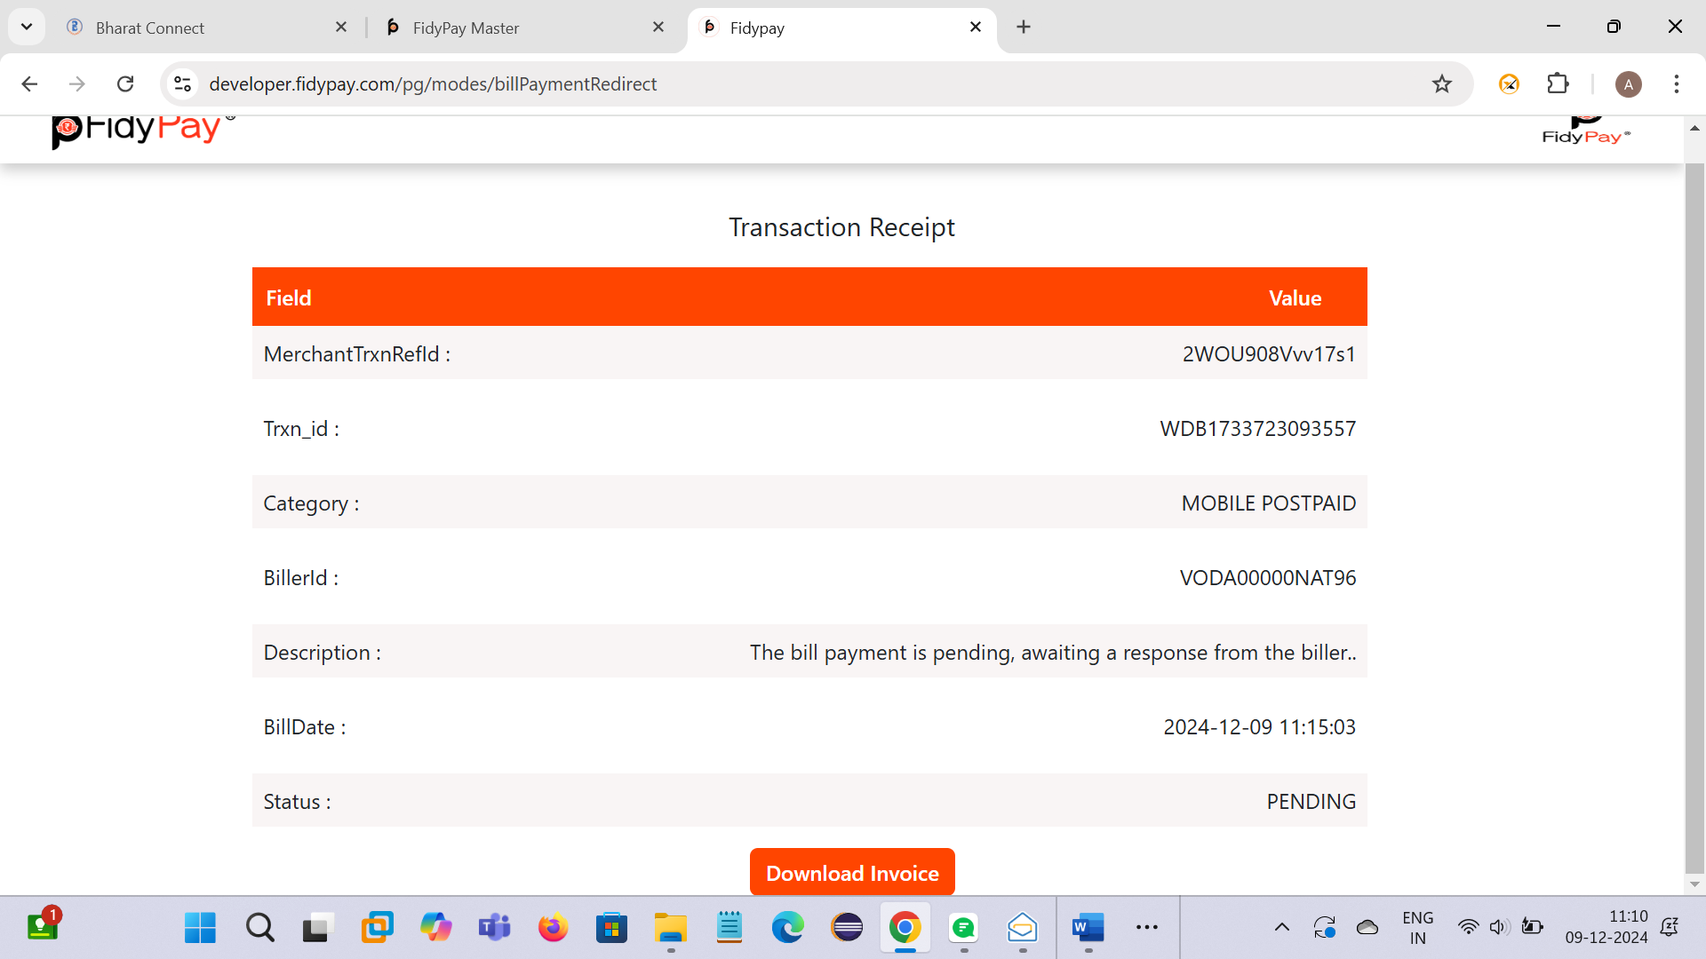

2.(Pass) Failed transaction & Failed amount should show in summary details.
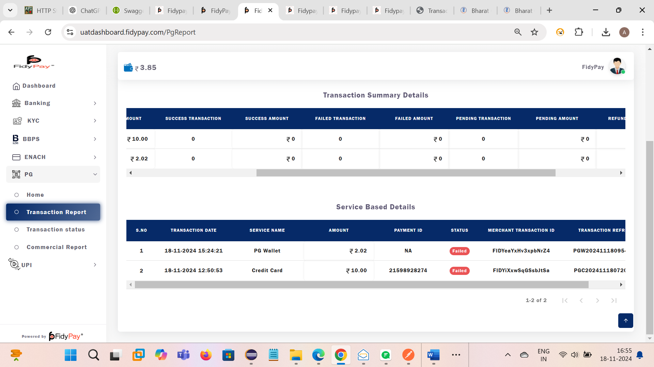

3. Transaction receipt should show proper at mobile view.
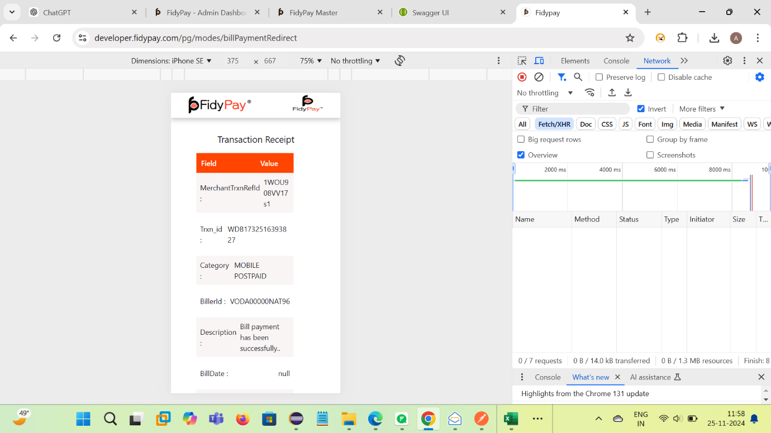
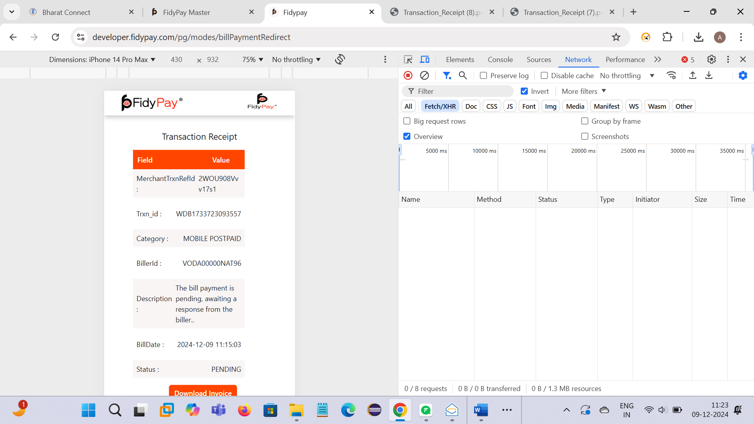

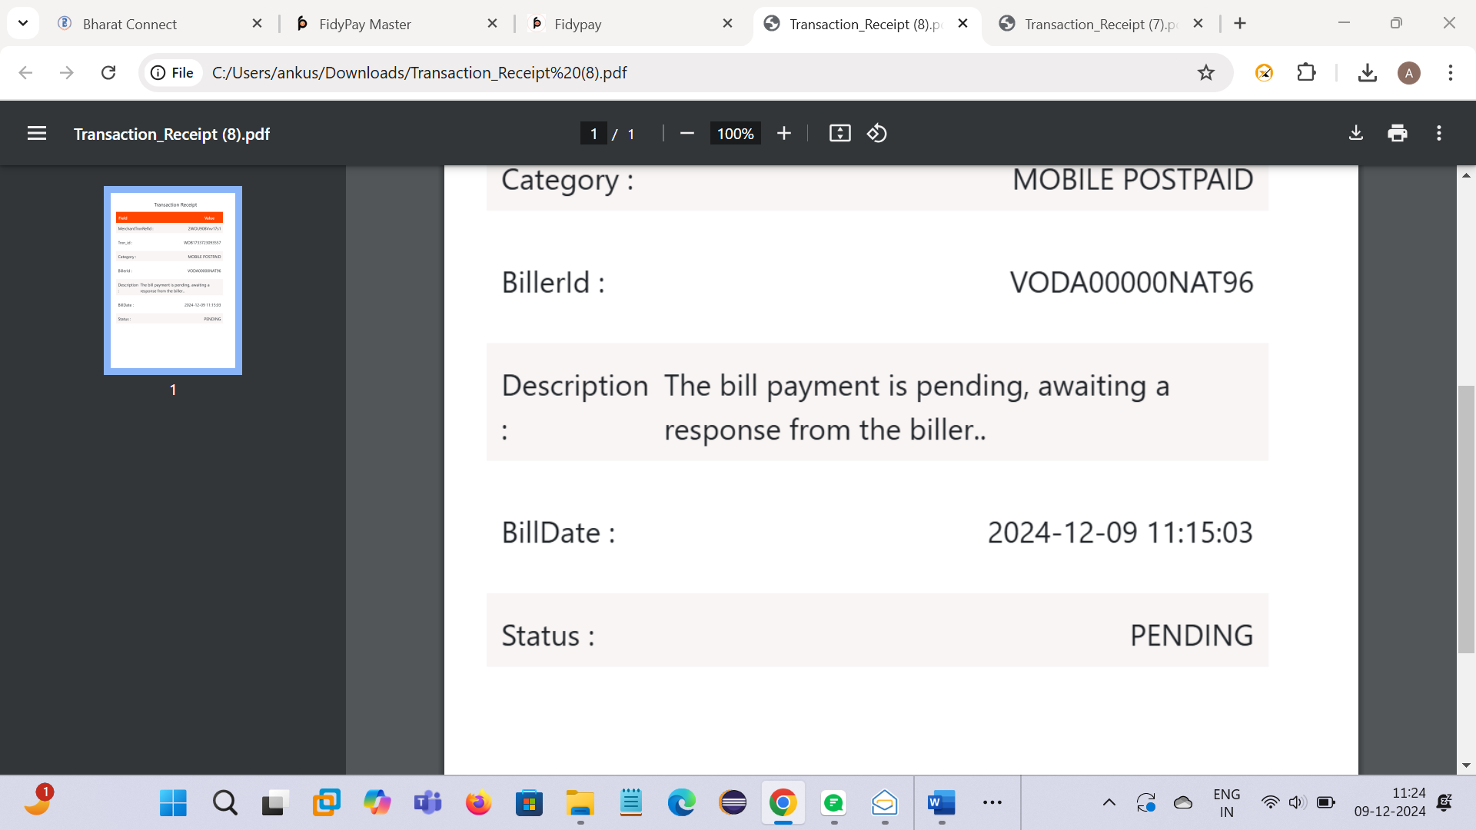

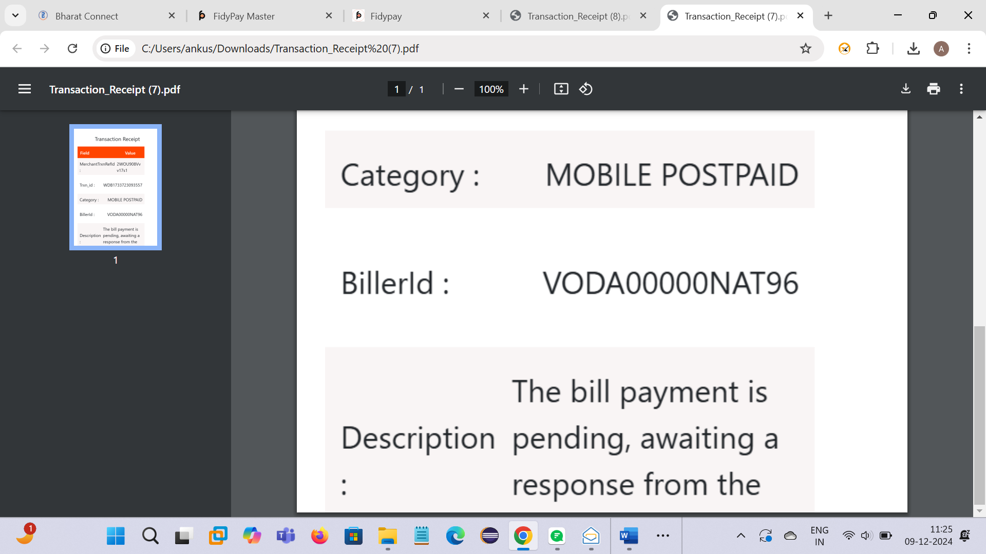

4. After pressing back button using mobile view Description get change as , something went wrong.
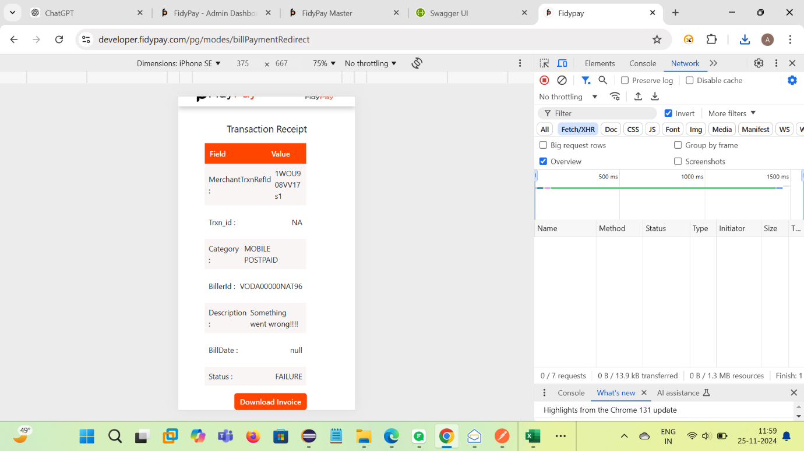

5. after pressing back button response show as bellow.
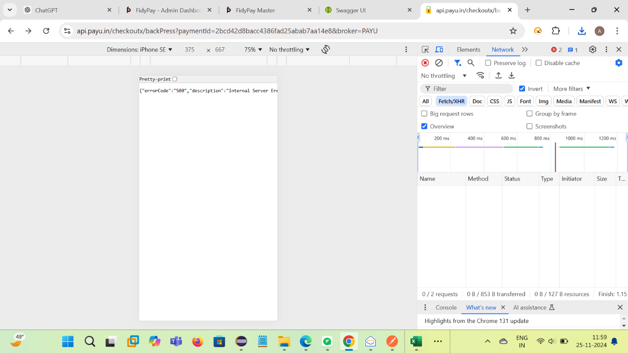

6.Using different credential for fetch bill & create order APIs transaction get succuss and also Mobile number show as NA.

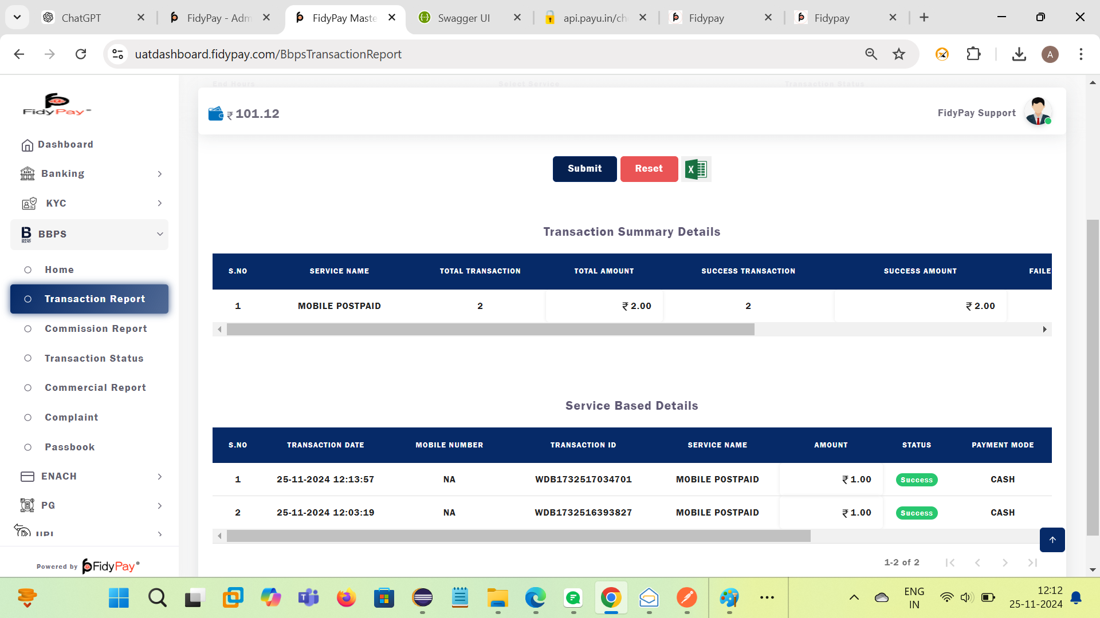

7.when we hit create order API more than one time and initiate a payment then response show as bellow.
